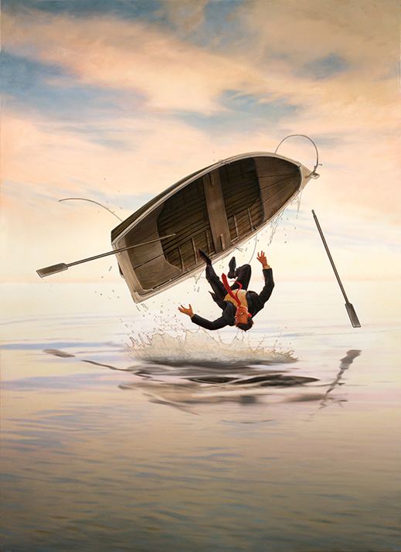

A Man who fell out of the ship
One day, the employees of a fishing company ran up to the CEO of this business and they screamed at him: “The Loch Ness monster is back! “ The clerk started to laugh. He laughed so much that he fell of his hot chair. When the workers saw it, they said: “We won’t work here until you kill the Loch Ness. “ At this moment he clerk started to laugh even louder. “I want to see it, guys! Let’s go! “ When they left the company building, they went to small harbour and the officer got in the boat. “If I don’t find it in next 30 minutes, you’re going to work double this week! “ said the clerk. He started to paddle on this big lake. After a few moments, he was somewhere in the middle of this big water area. With an ironic tone of his voice, he yelled at the employees. „ There’s nothing to see. “ Not a second passed and his boat flew into the air and he fell into the water. No one ever saw this man again.
Adam Slaninák

