YOU Tell the Story
Authors: Alice Burdová and Anna Krhutová
The girl, Sophia, always wanted to dance. So, when her friend called and said that there is a new ballet school, she was so thrilled and started jumping on the bed. She started looking forward to joining the school.
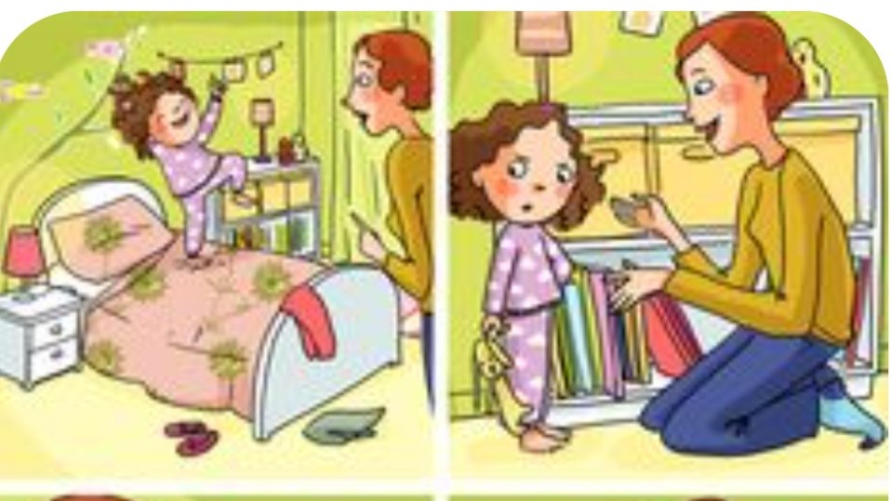
But her mother explained to her that ballet is harder than she might think and that she will have to work really hard. Sophia was uncertain for a moment, but then she smiled and said: „I can do it.”

In the ballet school Sophia often tripped and she was scared and wanted to give up. But she fought and started training harder and better.
On Sophia´s first performance there was her mom, who encouraged her. Sophia started dancing like no time before. The performance was amazing and so was Sophia. She was very happy, because she fulfilled her dream.
