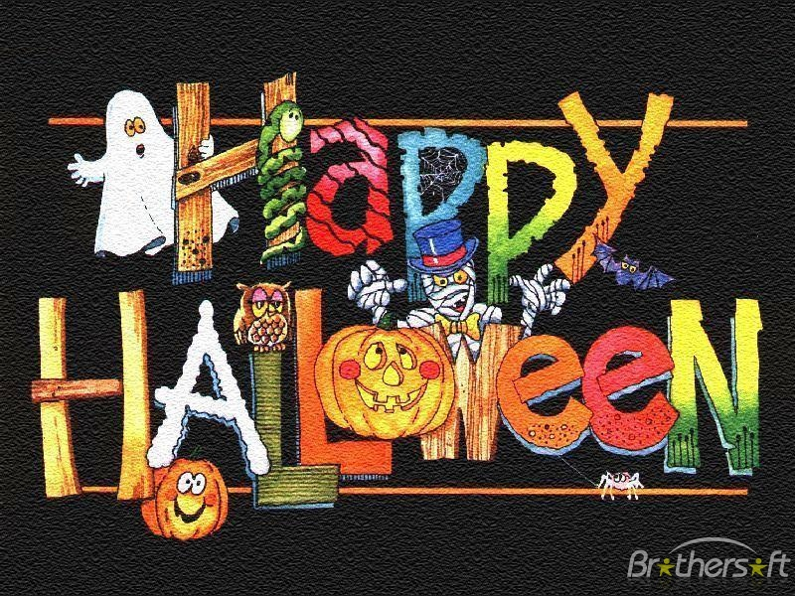

WIN

HALLOWEEN COMPETITION

FOR FRESHMEN

/1ST GRADE STUDENTS/

TERM: 1.C, 1.D - 24TH OCTOBER

1.E - 25TH OCTOBER
PLACE: CLASSROOM OR LANGUAGE LAB
TIME: YOUR ENGLISH LESSON
Make groups of four students. Do your best and solve the exercises about Halloween. Win great prizes!


