WIN
HALLOWEEN COMPETITION
FOR
THE BEST PUMPKIN RECIPE
(CLASSES 2.D, 2.E, 4.A, 4.B)

BECOME A COOK AND SHOW YOUR BEST

BE ORIGINAL
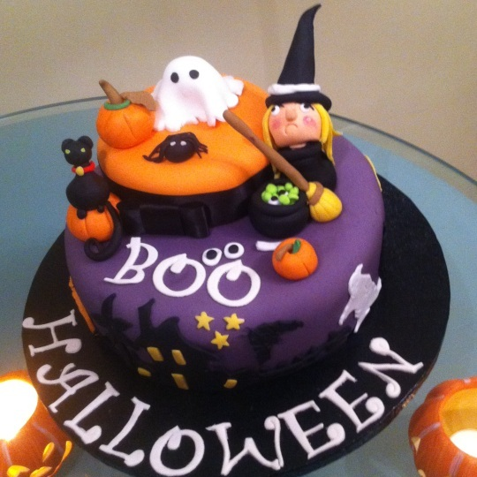
TERM: BRING A RECIPE AND TASTING
ON NOVEMBER 2ND , 2015

