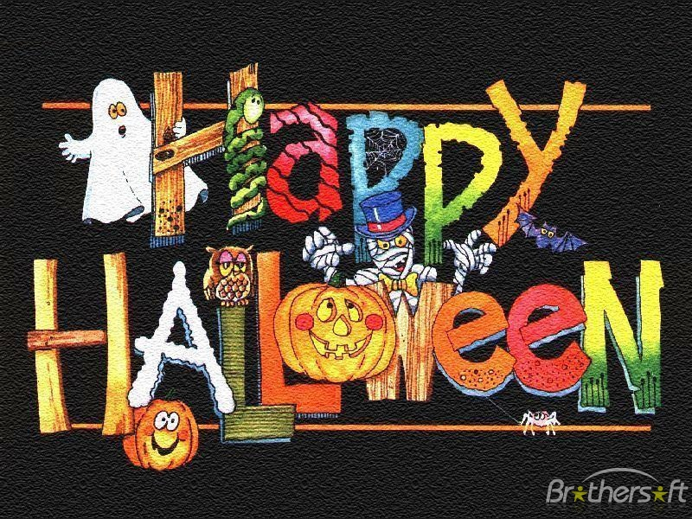

WIN
HALLOWEEN COMPETITION
FOR FRESHMEN
/1ST GRADE STUDENTS/

TERM: 26 TH - 27TH OCTOBER
PLACE: CLASSROOM OR LANGUAGE LAB
TIME: YOUR ENGLISH LESSON

Make groups of four students. Do your best and solve the exercises about Halloween. Win great prizes!


